*Intro:*

During the emergence of big data innovation, I find time series analysis can be an important tools that are helpful for many companies to utilize their historical data to support future strategic decisions. Times series analysis can have many drawbacks on accuracy of its prediction given many externalities that will not hold true over time. I think this system can still be useful to support manager’s decision. Additionally, I hope the knowledge I learned during the designing process can be helpful for me to explore more data analytical tools in the future.

*System explanation:*

This system is design based on a sample historical sales data sets of an airline company. The data only contains of two data types which are monthly passengers and dates.

The system is written using Python3.6, pandas, matplotlib.pyplot and fbprophet

* First step is to convert the raw data into format that we need to plot and analyze them later following this format

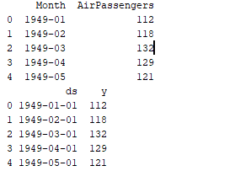

* Second step is plot the dataset so we get a visualization of what our data looks like

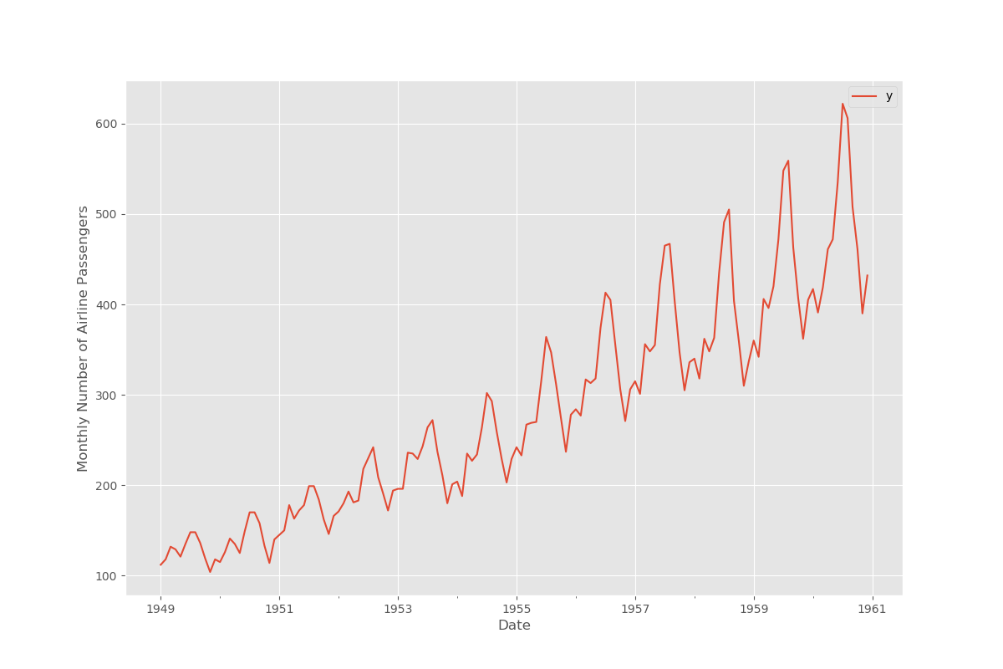

* After getting a visualization of our dataset, the system uses fbprophet function to detect any change point happened during the time given in our data. Change point analysis is a widely popular technique in data science industry to detect any sustained shifts, changes in trends and identify outlier regardless of the dataset’s scale. Here is a visualization of our data set with change points and potential change points are detected and marked with black dots. The shades over our line indicate potential change can happens to our sale at any given time. The company’s sales seemed to be very consistent over the years. Change-point analysis would be more useful if we analyzes daily or monthly sales, or if sales are more fluctuate over time.

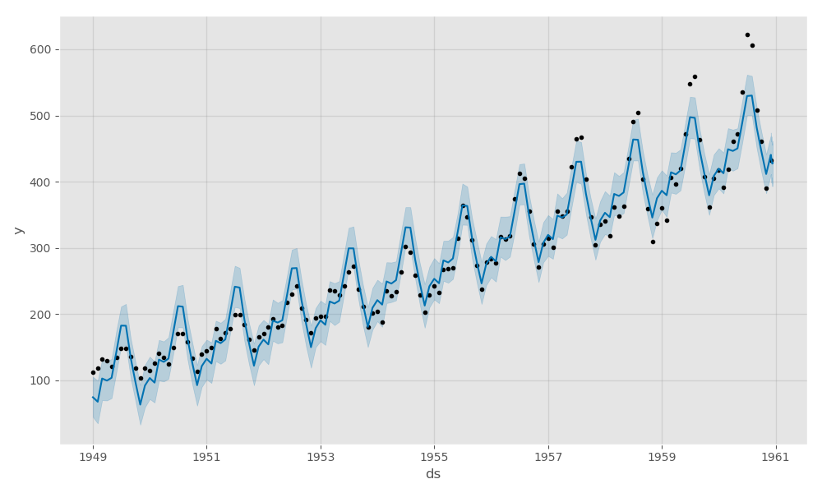

* Change-point analysis also helps us to make prediction on future sales. For our example, I choose to forecast what the airline company’s sales will be in the next 36 months with prophet. Of course we can use the prediction tools for any other amount of time periods if we want to.

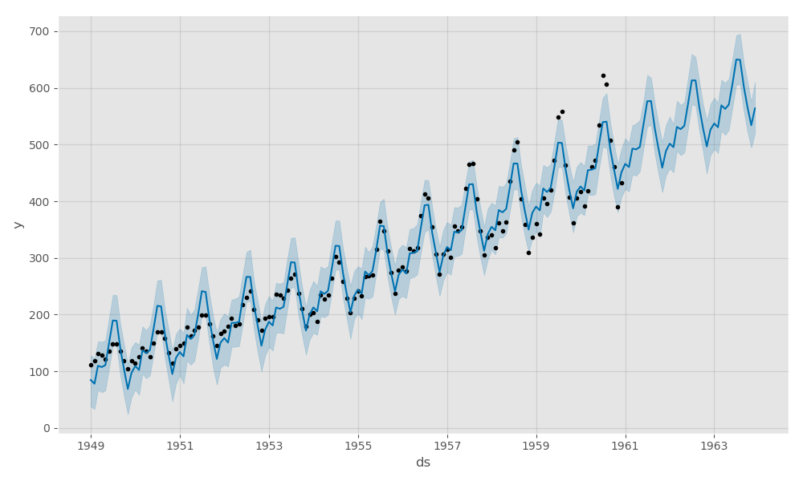

* The last functions included in the system is a visualization of monthly sales and trends in each year. Looking at the trend of yearly sales can help manager to adjust their price and cost accordingly to be more efficiency in their operation. In our example, managers can choose to increase their price during the summer, February and at the end of the year due to higher demand in the market. They can also choose to allocate their labors and resources to different areas during months with lower demand.

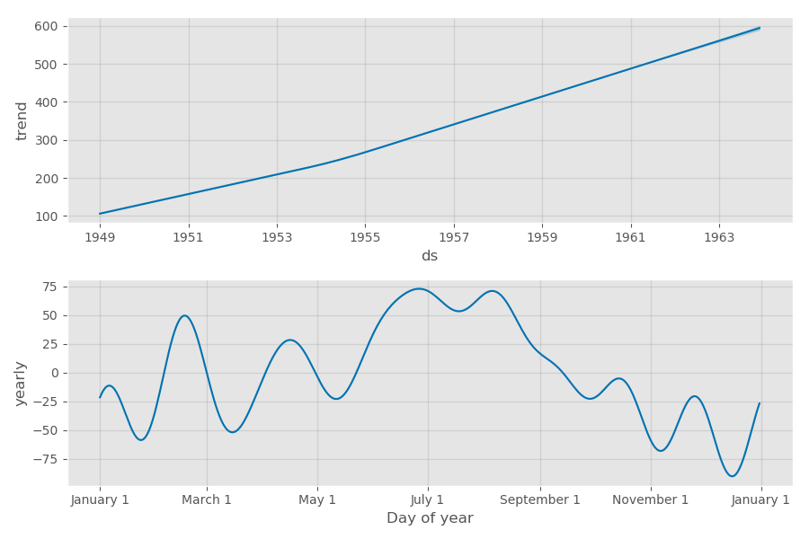

This Sale forecast and change-point analysis system using time-series analysis to support decision making process which can be used very flexible at many companies in different industry. Different uses fbprophet will be similar to what I illustrated in this project. Through this exercise, I found that fbprophet has many other useful functions for different type of data analysis.

This project was done with guidance and datasets from this tutorial:

<https://www.digitalocean.com/community/tutorials/a-guide-to-time-series-forecasting-with-prophet-in-python-3>